Name: _______________________________________________
Foundation Unit 8 topic test
Date:
Time: 50 minutes
Total marks available: 46
Total marks achieved: ______

Questions
Q1.
Write down a suitable metric unit for measuring
(a) the weight of a banana,

..............................................................................................................................................
(1)
(b) the volume of water in a fish tank,

..............................................................................................................................................
(1)
(c) the length of a lorry.

..............................................................................................................................................
(1)
(Total for Question is 3 marks)

Q2.
The shaded shape is drawn on a grid of centimetre squares.
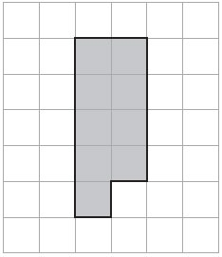
(a) Find the perimeter of the shaded shape.
. . . . . . . . . . . . . . . . . . . . . .
(2)
(b) On the grid below, draw a square with the same area as the shaded shape.
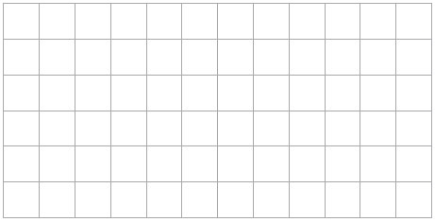
(1)
(Total for Question is 3 marks)

Q3.
Change 530 centimetres into metres.
........................................................... metres
(Total for question is 1 mark)

Q4.
There are 1.5 litres of water in a bottle.
There are 250 millilitres of water in another bottle.
Work out the total amount of water in the two bottles.
...........................................................
(Total for question is 3 marks)

Q5.
Here is a cuboid.
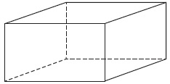
The following sentences are about cuboids.
Complete each sentence by writing the correct number in the gap.
(a) (i) A cuboid has ................................. faces.
(ii) A cuboid has ................................. edges.
(iii) A cuboid has ................................. vertices.
(3)
Here is a different cuboid.
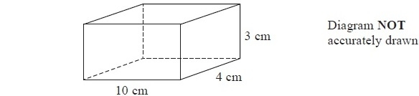
(b) Work out the volume of the cuboid.
........................................................... cm³
(2)
(Total for Question is 5 marks)
Q6.
Here is a square–based pyramid.

(i) How many faces does the pyramid have?
...........................................................
(1)
(ii) How many edges does the pyramid have?
...........................................................
(1)
(Total for question = 2 marks)

Q7.
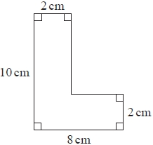
Work out the area of the shape.
........................................................... cm²
(Total for question is 2 marks)

Q8.
The diagram shows a triangular prism.
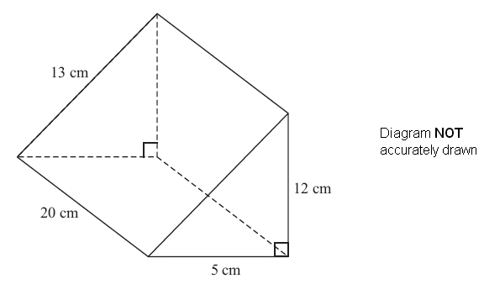
Work out the total surface area of the prism.

. . . . . . . . . . . . . . . . . . . . . . cm²
(Total for Question is 3 marks)

Q9.
Here is a diagram of Jim's garden.
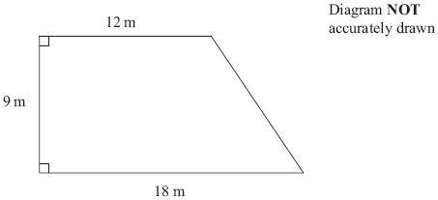
Jim wants to cover his garden with grass seed to make a lawn.
Grass seed is sold in bags.
There is enough grass seed in each bag to cover 20 m² of garden.
Each bag of grass seed costs £4.99
Work out the least cost of putting grass seed on Jim's garden.

£...........................................................
(Total for Question is 4 marks)

Q10.
Carpet tiles are going to be used to cover a floor.
The floor is a 1200mm by 1000mm rectangle.
Each carpet tile is a 40cm by 30cm rectangle.
Exactly 10 carpet tiles can be used to cover the floor completely.
Show in a labelled sketch how this can be done.

(Total for question = 3 marks)

Q11.
Here is a solid cuboid.
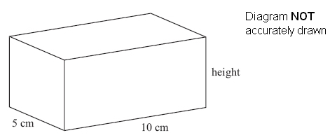
The cuboid has a width of 5 cm and a length of 10 cm.
The cuboid has a total surface area of 280 cm².
Work out the height of the cuboid.

. . . . . . . . . . . . . . . . . . . . . . cm
(Total for Question is 4 marks)

Q12.
* Marc drives a truck.
The truck pulls a container.
The container is a cuboid 10 m by 4 m by 5 m.
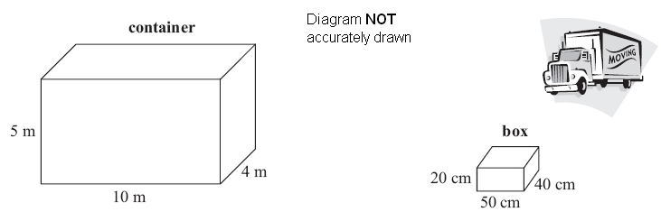
Marc fills the container with boxes.
Each box is a cuboid 50 cm by 40 cm by 20 cm.
Show that Marc can put no more than 5000 boxes into the container.

(Total for Question is 4 marks)

Q13.
A pattern is made using identical rectangular tiles.
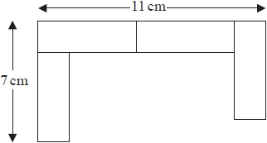
Find the total area of the pattern.
........................................................... cm²

(Total for question is 4 marks)

Q14.
The diagram shows a sand pit.
The sand pit is in the shape of a cuboid.
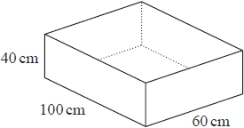
Sally wants to fill the sand pit with sand.
A bag of sand costs £2.50
There are 8 litres of sand in each bag.
Sally
"The sand will cost less than £70"
Show that Sally is wrong.

(Total for question is 5 marks)

Examiner's Report
Q1.
All three parts of this question were answered very well. Incorrect answers were often the result of candidates giving an imperial unit rather than a metric unit, with the most common ones being pounds in part (a), gallons in part (b) and feet in part (c).

Q2.
Counting the number of centimetres on the perimeter proved a challenge for many with the bottom of the shape causing the most problems. A significant number of candidates failed to give the units of cm with their answer, this was frequently omitted or else the wrong units, eg. cm² were given. A common incorrect answer from the confusion of area with perimeter was 9 cm². In part (b) a significant number of candidates drew a shape other than a square with an area of 9 cm² or drew a shape with an area of 14 cm², again confusing area with perimeter. Others drew a square of the wrong area.

Q3.
No Examiner's Report available for this question

Q4.
No Examiner's Report available for this question

Q5.
Candidates were rarely successful with all parts of (a) with errors appearing to mix up the terms as well as suggesting miscounting. Edges and vertices appeared to be the most commonly interchanged.
In (b), where the correct method for volume was given, some candidates made arithmetic errors with their calculation of 3 × 4 × 10. When the correct method was not given, many attempted to add the 3 given lengths or find the area of a single face or complete surface area.

Q6.
No Examiner's Report available for this question

Q7.
No Examiner's Report available for this question

Q8.
Over two thirds of candidates gained no marks on this question with less than 5% giving a fully correct response. Most candidates did not display knowledge of surface area but instead set about finding the combined length of the edges or simply multiplied three or four of the given numbers together. When candidates did appreciate the need to find areas they often forgot to divide by 2 when finding the area of one of the triangular ends. The sloping face of 260cm² was often found and added to a single value of 60. The most successful candidates showed well organised working labelling the different parts of their area calculations with names or diagrams of the shapes involved.

Q9.
Very few candidates used the given formula for the area of a trapezium to find the area of the garden, most choosing instead to find the sum or difference of the areas of a rectangle and triangle. Unfortunately, far too often, the area of the triangle was incorrect, usually simply 54 (6 × 9). Candidates who found the correct area usually went on to complete the solution correctly, although multiplication of £4.99 by 6 or 7 was often strewn with error. Some lost the final accuracy mark for rounding 7 x 4.99 to 7 x 5 and deducting the wrong number of pence, usually 5p not 7p.

Q10.
No Examiner's Report available for this question

Q11.
This was almost always treated as if the 280 was volume. Some appeared to recognise that is wasn't volume and they took the area from 280, but then reverted to volume. Some thought that the height must be the same as the width and gave the answer 5 cm. Very few correct answers.

Q12.
Very few candidates were able to show a clear set of steps starting with the information in the diagram and leading to the conclusion of 5000 being the maximum number of boxes that could fix into the container. Most candidates were only achieving 1 or 2 marks. Where candidates achieved M2 this was usually for correctly calculating a volume and showing that they could convert 5m, 10m or 4m to centimetres. Where candidates only achieved M1 this was usually for correctly calculating a volume.
Common errors included the use of incorrect conversion facts 1m=10cm or 1m=1000cm, finding the surface areas or just adding the side lengths.
Candidates often tried to fix their calculations to get 5000 or did not realise that 5000 was correct and wrote a contradictory statement, however, they did realise that they needed to show working out and not just offer a worded answer. Many candidates were unaware of the need to convert all the measure to the same unit hence failed to gain the second M1 for division as their values were the wrong way round.

Q13.
No Examiner's Report available for this question

Q14.
No Examiner's Report available for this question
Mark Scheme
Q1.
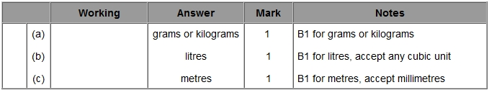

Q2.
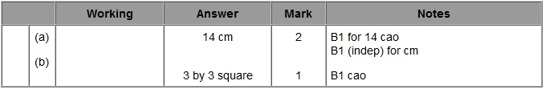

Q3.
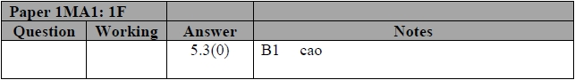

Q4.
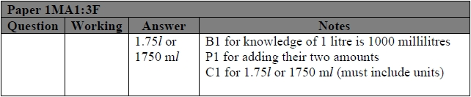

Q5.
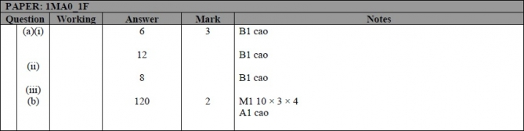

Q6.
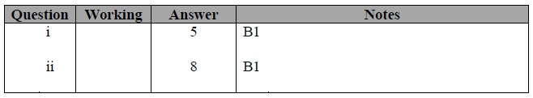

Q7.
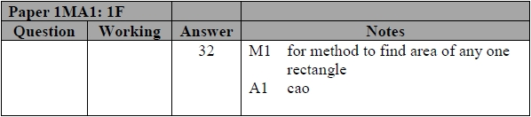

Q8.
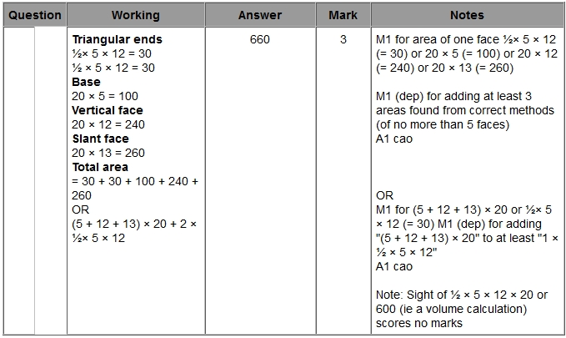

Q9.
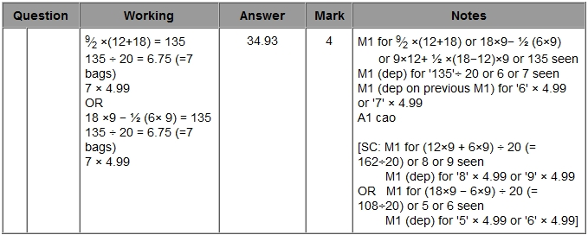

Q10.
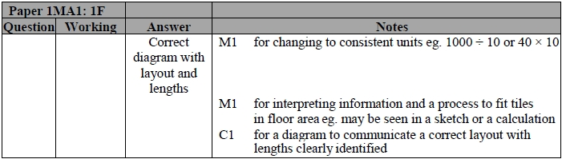

Q11.
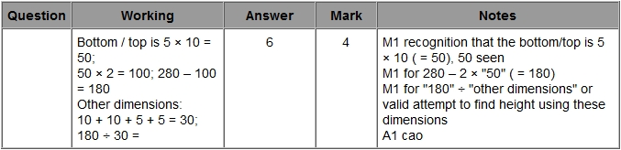

Q12.
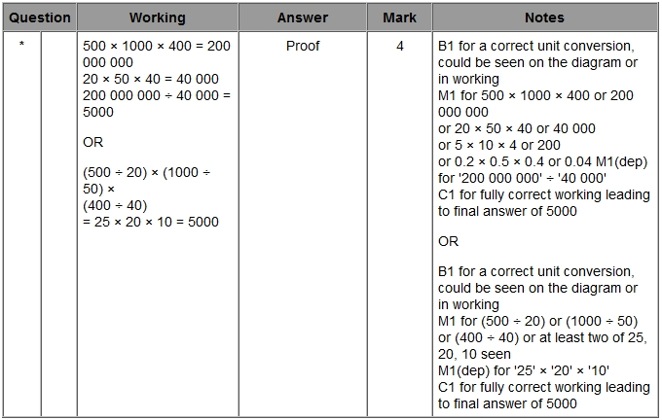

Q13.
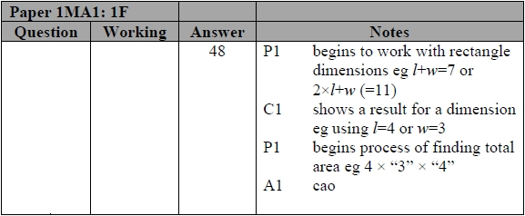

Q14.
